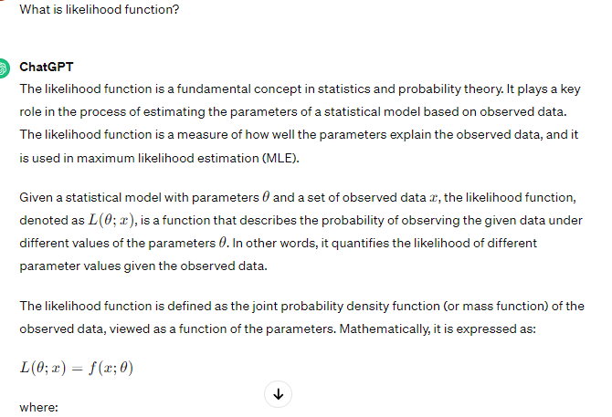

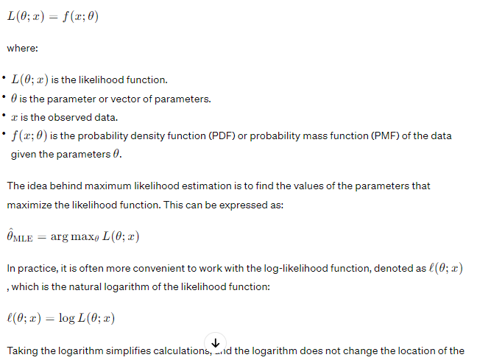

Taking the logarithm simplifies calculations, and the logarithm does not change the location of the maximum point, which is what matters for finding the maximum likelihood estimates.

The likelihood function is a powerful tool in statistical inference, providing a formal way to make inferences about unknown parameters based on observed data. It is widely used in various fields, including biology, economics, engineering, and many others.